**BLOCKCHAIN-BASED REAL ESTATE**

* Member:
* Dương Hoàng Linh
* Nguyễn Minh Tâm
* Nguyễn Phi Hùng
* **Fifth Report (28/02/2019)**

1. **REAL ESTATE SMART CONTRACT:**

* We use the following contracts for our project:+ Property

+ PropertyRegistry

+ MetadataRegistry

1. **Property:**

* In this contract will contain two contract: Property and PropertyRegistry.
* The Contract Property will use variables like:

+ address owner: save the address of the owner

+ address renter: save the address of the renter

+ string alias: property name

+ string geohash: represents the geographical position of the property.

+ address[] rentalhistory: save rental history

* Contract Property will contain the following functions:

+ Property: initialize a new property

+ Changerenter: change of tenant (can be used to revoke rental rights)

1. **PropertyRegistry:**

* In this contract will contain some important components as follows:

+ Event PropertyAdded:



+ Function PropertyRegistry: call the Property function in contract Property to register a new property. This function will return the address of the newly registered property.

+ Function GetProperty: get information about registered property.

1. **MetadataRegistry:**

* This Contract will help to link or removelink of created properties with ipfs hash (containing images, information about properties)

1. **WORKING**

* We have successfully tested some functions such as initializing and registering a property, getting the information of a property on the web interface.
* We are looking for solutions to handle data (ipfs hash) associated with property and solutions to authenticate a person who is the owner of that property.

1. **ID VERIFICATION WITH DIRO CRYPTO KYC**
2. **What is KYC?**

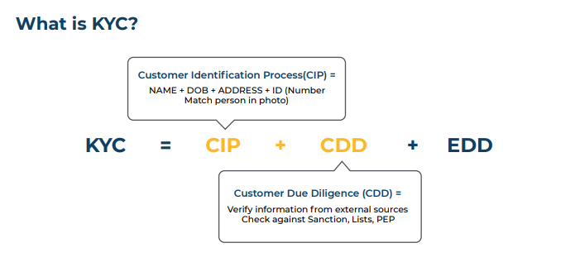

* "Know Your Customer" or KYC is an important term used by businesses and refers to the process of verification of the identity of the customers and clients either before or during the start of doing business with them.
* KYC is done as a precaution against illegal activities like money laundering, bribery or corruption. It helps the government and businesses keep track of such activities or suspect them beforehand.

1. **List of documents that can be submitted as proof of identity and address:**

* Passport
* Driving Licence
* Voters' Identity Card
* PAN Card
* Aadhaar Card issued by UIDAI
* NREGA Card

1. **Why KYC is so important?**

* Know your customer (KYC) practices are developed worldwide to prevent theft, financial fraud, money laundering and terrorist financing. .
* The main KYC goal is to enable debt providers to know and better understand their borrowers, and therefore manage their risks providentially.
* Whether an investor or a debt provider, all stakeholders you should ensure they know their your client’s identity, its previous and current financial situation, the purpose of the transaction and what the client aims to achieve from it.
* As real estate transactions usually involve a chain of investors buying and selling properties, debt providers are more and more meticulous in defining their KYC requirements; they usually insist on further transaction information to ensure they know where their funds will ultimately go in order to better manage their risks.

1. **DIRO crypto KYC solution:**

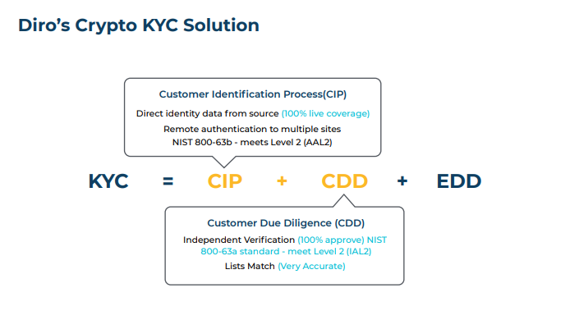

* Diro allows capture of web documents behind secure logins across the web and government websites by individual consumers. It immutably captures the secure provenance information behind SSL/TLS using a cryptographic hash that’s added to the blockchain.

+ Capture original documents and eliminate the need for verification

+ Eliminate stolen identities and document fraud using fresh timestamps

+ Remotely authenticate individuals by proving command and control of identity and access.

* Access based authentication – is now an accepted standard for validating mobile numbers via sending a one-time-passcode. Diro extends that by having users authenticate against multiple third party websites to validate the identity.

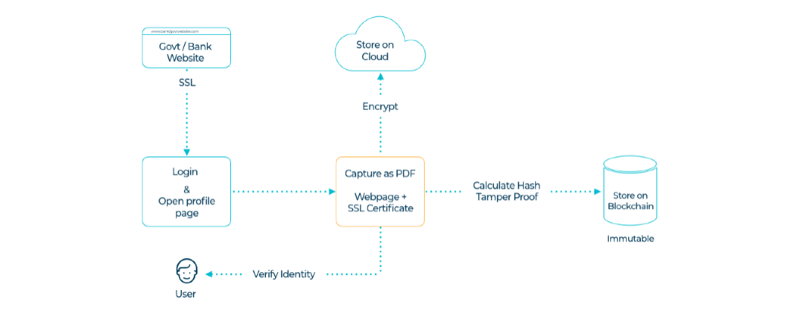

1. **Cryptographically Verifiable Documents**

* Customers submit their own KYC documents using our patent pending antiimpersonation & anti-fraud technology. Customers first need to install our app on their smartphone or install our Firefox Add-ons.

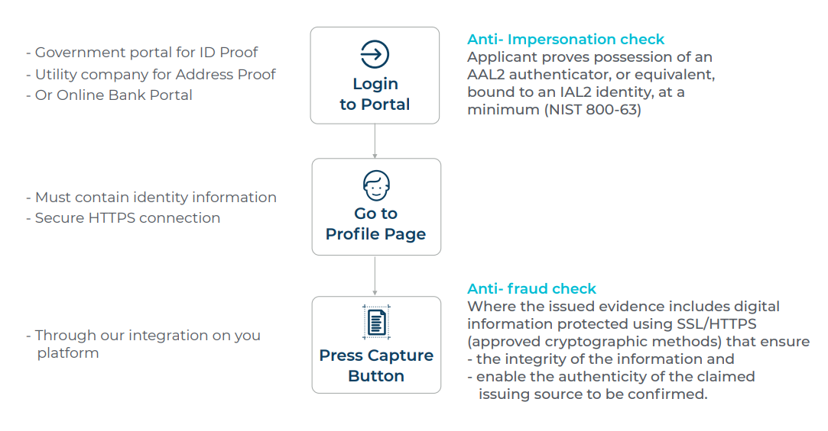

1. **Remote Customer Identification Process**

* Cryptographically Verified Documents (CVD) for a key component in our remote Customer Identification Process (CIP). Traditional 1st & 2nd generation remote CIP are weak processes and a strong remote CIP is now possible through our anti-impersonation & anti-fraud CVD generating process (explained in point 1 above).

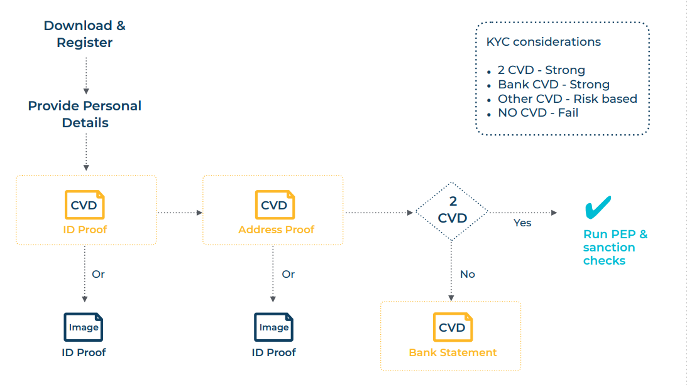

1. **REFERENCES:**

* <https://www.goodreturns.in/classroom/2016/01/what-is-kyc-what-are-the-documents-required-kyc/articlecontent-pf9460-422032.html>
* <https://avamorecapital.com/why-kyc-know-your-customer-is-so-important/>
* <https://docs.wixstatic.com/ugd/fae167_b71480c5beaa426fa45f112e89359231.pdf>